# Learning about urban climate solutions

William F. Lamb1*, Felix Creutzig1,2, Max C. Callaghan1,3, Jan C. Minx1,3

1 Mercator Research Institute on Global Commons and Climate Change, Torgauer Straße 12-15, EUREF Campus #19, 10829 Berlin, Germany

2 Technische Universität Berlin, Straße des 17. Juni 135, 10623 Berlin, Germany

3 School of Earth and Environment, University of Leeds, Leeds LS2 9JT, UK

* [lamb@mcc-berlin.net](mailto:lamb@mcc-berlin.net)

**Climate mitigation research puts increasing emphasis on cities. Yet in the assessment of urban climate solutions, case studies are an unexploited resource. The overall size, geographic scope and topic content of urban case studies remains basically unknown, resulting in few attempts to synthesise the bottom-up qualitative evidence on mitigation prospects in cities. We use scientometric and machine learning methods to produce a comprehensive evidence map of urban case studies. With almost 3,500 cases, a wealth of evidence is available. However, a number of practical and conceptual challenges hinder systematic learning. There are strong size, regional and topic biases in case study coverage, and sparse efforts to conduct comparative analysis and systematic reviews. We show how quantitative typologies can be blended with qualitative knowledge from cases and argue that such integrative research approaches are essential on the path towards a more synthetic global urban science.**

When it comes to urban mitigation solutions, the key questions are: what works, for whom, under what conditions, and why? Little progress has been made so far. With no consistent epistemology, enormous variety in boundaries of analysis, and a lack of formal research synthesis, urban mitigation solutions remain diffuse and under-exploited 1–3.

Systematic learning hinges on aggregating information about individual cities. Recent work emphasises a quantitative direction to this work, using ‘big data’ and typologies to identify structural similarities and path dependencies of development 4. In this sense, groups of similar cities might draw from the same pool of solutions, or learn from early pioneers in climate policy. To make this strategy actionable, however, it will be critical to complement quantitative typologies with an understanding of underlying political and social conditions – the decisive factors that ultimately shape or hinder urban transformations 5.

To this end, a sizable body of case study research exists for individual cities, as well as comparative studies across multiple urban settings 6. These cases often include a rich variety of contextual information and analysis on urban-scale projects and reforms, yet are not well represented in the scope of assessment literature on cities. The typical presentation of such evidence in assessment studies takes an anecdotal rather than analytical form – as dedicated boxed sections, as examples of particular phenomena, or within curated libraries of initiatives. Above all, a lack of rigorous literature selection procedures in assessments (and in reviews generally) means that potentially relevant cases remain undiscovered – a hidden treasure that is increasingly buried under the exponential growth of publications 3.

Urban case studies can add to our understanding of climate mitigation solutions, but an overview of the field is urgently needed. Which cities do we know about? What topics do we know about? What comparative and secondary analysis is there of cases? And how can generalizable knowledge be derived from urban cases? In this perspective we address these questions, with a view to developing a more systematic agenda for aggregating knowledge on urban solutions. Overall we identify a rich and varied case study literature, albeit one with regional and topic biases, and a distinct lack of learning on these studies. We then propose approaches that blend quantitative data and bottom-up information from cases to inform urban climate solutions.

As a starting point to our analysis, we obtain a sample of urban mitigation articles using a search query that combines synonyms for “urban” and “mitigation” in the Web of Science and Scopus literature databases (see methods). Our interpretation of case study research is straightforward: if an article mentions a city name in the abstract or title, we assume it is a case study located in the city (or cities) mentioned. Our dataset for the proceeding analysis consists of 3,440 case study publications. We use language processing methods to extract relevant meta-data on case study locations, topics, review studies, and other information.

## Urban case studies are biased towards large cities and the global North

Cities vary in many dimensions, including size, wealth and infrastructure development. As different types of cities face different challenges, learning about solutions depends on a balanced coverage of case study research. An obvious question therefore arises: which cities do we actually know about?

Figure 1 shows the spread of case study research across different city sizes, from a small number of familiar ‘mega-cities’ (over 10m inhabitants), to dozens of smaller national and regional capital cities (1-10m), and hundreds of yet smaller metropoles. The majority of research so far has focused on larger cities, with a small number of mega-cities receiving particular attention: Beijing (284 articles), New York (146), Shanghai (140) and London (117). Other cities are mentioned in fewer than 100 articles each.

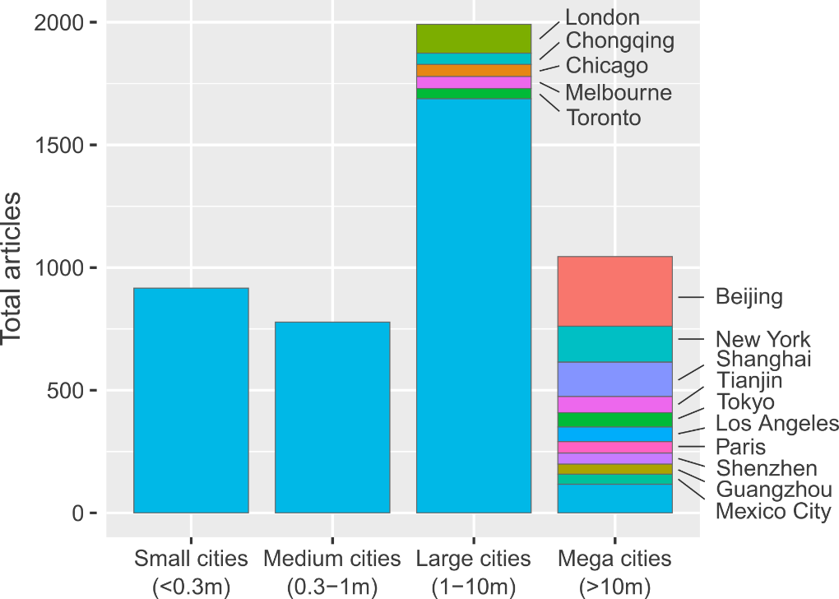

**Figure 1: Number of urban climate mitigation articles, grouped according to city size.** The 15 most frequently studied cities are labelled. Population data from ref 7, using agglomeration data where available.

Considering the global distribution of population, the current focus on larger cities does not seem to be justified. Just 10% of the world’s urban population lives in mega-cities, compared to 40% in small cities – yet both groups are treated equally in research, each receiving approximately 20% of the case studies we find (Figure 2). A particularly stark divide can be seen in Asia, where the low proportion of mega-city inhabitants (10%) is served by over 40% of the urban case study literature in this region. Although mega-cities are fast-growing in most regions (SI Text Figure 1) this unbalanced focus leaves smaller urban centres consistently under-represented. This pattern is repeated for literature citations, with progressively larger cities receiving, on average, more citations (SI Text Figure 2).

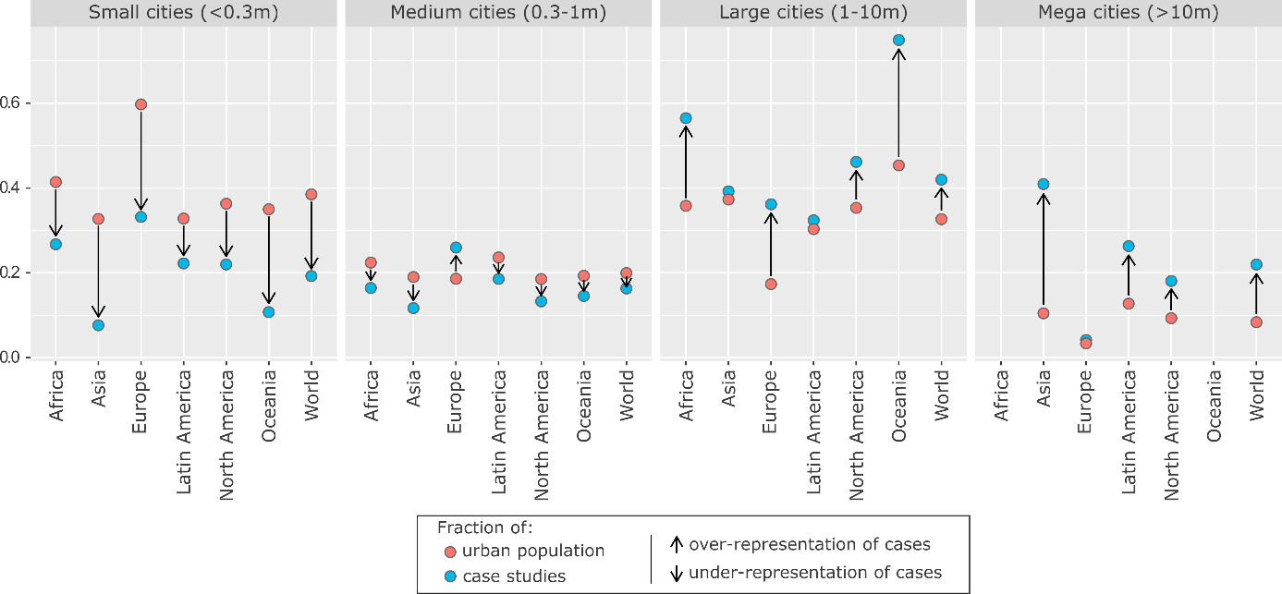

**Figure 2: Size bias in urban mitigation case study research.** Fractions of population and case studies are relative to regions. Population data from ref 7, using agglomeration data where available.

Regionally, we also observe a clear bias towards Europe, North America and Oceania, which receive an outsized share of articles relative to their small proportion of the global urban population (SI Text Figure 3). Looking forward to urbanisation trends in 2030, the least well represented region, Africa, has the fastest growing cities (SI Text Figure 1). And the least well represented segment, small Asian cities, will have the largest share of the global urban population (SI Text Figure 4). Hence, the world regions and city scales with most future relevance in terms of total urban population and growth dynamics are systematically underrepresented in the literature.

With the window on the 1.5°C and 2°C goals rapidly closing it is essential to immediately initiate infrastructure transformations wealthier Northern cities. The current focus of case study research on these cities is congruent with current debates in climate ethics, that responsibility for drastic mitigation action rests on the shoulders of high-emitters 8. Nonetheless, the majority of future urban emissions growth will originate from Asian and African cities, where ongoing processes of urbanization and infrastructure development provide a window of opportunity for establishing urban designs consistent with low-carbon mode choices and building use 9. Guiding these growing cities towards compact, low-carbon urban forms requires a major shift in research focus.

Redressing the lack of focus on smaller cities emerges as a second priority. Yet herein lies a more fundamental problem: whereas large cities are few in number and can be reasonably sure of dedicated case studies that address specific policy needs, smaller cities are far more numerous, rendering direct coverage of all such cities near impossible. Almost 60% of global mega-cities (17/29) are directly researched in our database of case study literature. This figure declines to 23% (281/1228) for medium-sized cities (SI Text Figure 5). We can safely presume that coverage is even worse for small cities, even though data on the number of small agglomerations remains incomplete. As a result, learning about solutions across a comprehensive set of contexts and scales requires major innovations in the synthesis of case study knowledge.

## A topic map of urban mitigation case studies

Urban climate mitigation is a broad church, encompassing research on a variety of sectors (e.g. buildings, transport, waste), policies (infrastructure provisioning, behavioural incentives) and overarching concerns (human well-being, sustainability). The relevance of a particular research stream for policy learning depends on the cities and context at hand. Some urban issues are known to be ubiquitous – car-centric transportation infrastructures often result in a variety of harms to human health, civic life and equal access to services – while others are far more location specific, such as high heating demands in northern latitudes, or climate adaptation needs in low-lying coastal cities. Understanding the scope of mitigation research carried out on cities is an entry point to structured learning on solutions.

However, it is increasingly difficult to track the development of rapidly growing scientific fields. We therefore turn to natural language processing methods to explore the thematic content of urban case studies. Using the identified corpus of 3,440 case studies we construct a matrix of documents and the words contained in their abstracts, factorising to obtain the ‘topics’ that describe commonly co-occurring words across the document set (we subsequently refer to this as “topic modelling”; see methods). In essence, machine reading software discovers the latent topics that permeate the document set and categorises each document accordingly, substituting for the laborious task of reading and tagging each article by hand. The unsupervised ‘learning’ in this method also reduces subjectivity in one’s overall assessment of a body of literature.

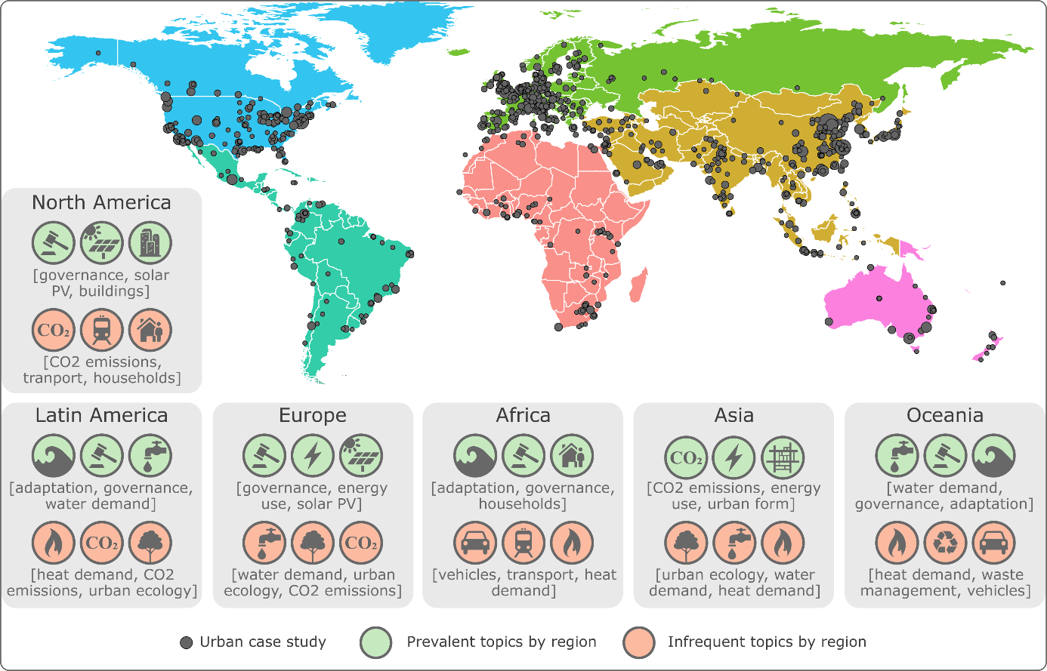

**Figure 3: Global coverage of urban case studies.** Cities are scaled by the number of identified case studies. For each region, the topic distribution of associated case studies is summed, and the highest/lowest scoring topics are shown (see Methods).

Demand-side topics (i.e. those that focus on end-use sectors and behaviours) are prevalent in the case studies. These include including transportation, waste management, and energy and heat demand in buildings – alongside issues of urban governance, urban form and CO2 emissions accounting (SI Text Table 1). Of the 17 topics we identify, only a single focuses on supply-side mitigation – on solar PV. Because topic modelling ascribes multiple topics to each document, combinations of issues can be found. Hence we also see a wider set of sustainability concerns represented within the urban mitigation cases, including air pollution, water demand, urban ecology and climate adaptation.

Topics are not evenly distributed across different urban regions. Scaling up the analysis from individual documents to groups of documents, we observe that emissions accounting and urban form are frequent subjects of case study research situated in Asia (Figure 3), perhaps reflecting strong investments into engineering disciplines and education in China and South Korea (44% of all students in China graduate in science & engineering, compared with 16% in the US) 10. This contrasts with the ubiquity of urban governance research, capturing research on policies and policy-making, in all other regions. And despite specifying no climate adaptation keywords in our search query, it emerges as the most prominent topic in the cities of Africa, Latin America and Oceania, reflecting a commitment to joint case studies on both adaptation and mitigation in these regions.

Individual cities are hotspots for particular mitigation topics. Low-carbon transportation case studies are well developed for Beijing and London, but scarcely researched in New York City, Tianjin, Los Angeles, Tokyo and Chicago (Figure 4). Emissions accounting dominates the case study work on top-tier cities in China (Beijing, Shanghai and Tianjin), while topics around urban ecology, water demand and waste management are overlooked here – at least in the mitigation focused literature we identify. Table 2 in the SI text lists the articles we identify for the largest urban centre in Africa, Cairo, showing not just the scarcity of studies on this city, but the potential of topic modelling to rapidly expose the main research to date, in this case a narrow focus on building design and technologies.

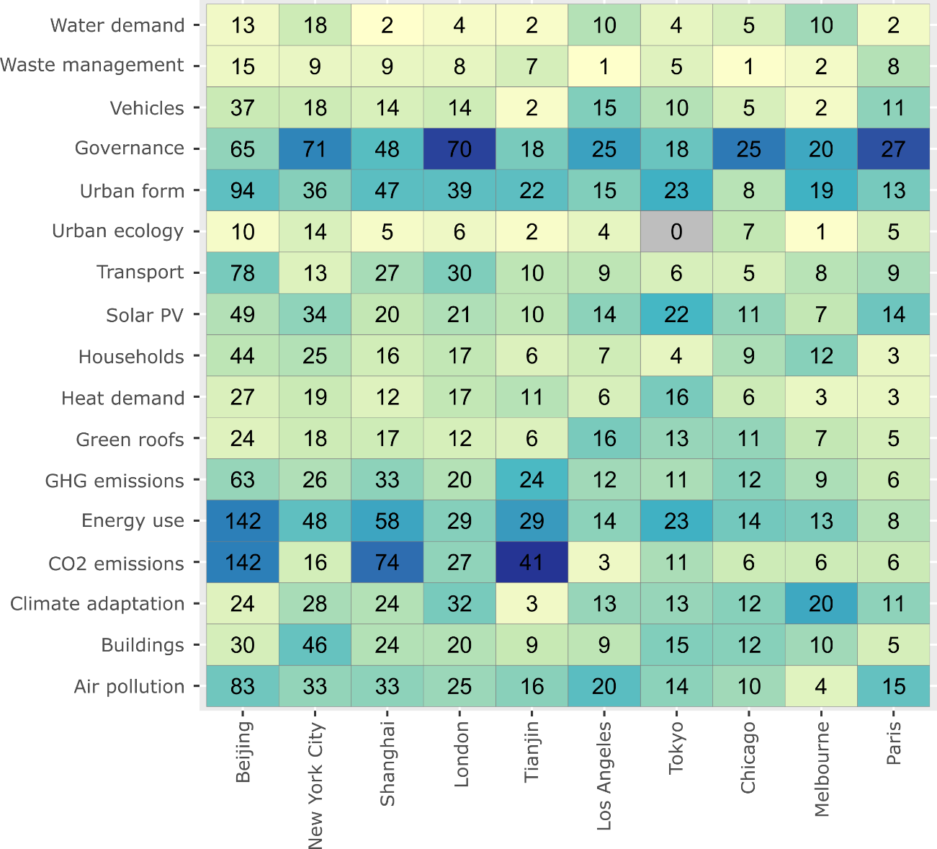

**Figure 4: Number of mitigation studies by city and topic.** 10 cities with the most publications are listed. A city/topic combination is counted if the publication meets a minimum topic threshold of 0.02 (see Methods). Publications with multiple topics are double-counted, often when topics are strongly correlated (e.g. Energy use and CO2 emissions). The colour scale is normalised by city, indicating the main topic focus of case study literature within each city. Note: because our literature search included keywords only for climate mitigation, indicated studies are not comprehensive, particularly where large and relevant sectoral literatures exist but are not yet framed in terms of emissions reductions (e.g. transport) 6.

A key mitigation topic and bottleneck in reaching very low levels of energy demand is urban form –i.e. the spatial characteristics of a city, including density and land-use configuration 11,12. Urban form is indeed one of the most prevalent topics in the set of case studies, after governance and energy use (SI Text Table 1). Yet an important question in the context of learning is whether future urbanisation challenges (or opportunities) are being anticipated and mitigated, rather than responded to post-hoc. We therefore search abstracts directly for keywords that might indicate such “forward looking” studies (e.g. “scenario” or “2050”; see methods for more detail), finding 333 documents that mainly emphasise CO2 emissions accounting, transportation and air pollution (SI Text Table 3). Notably, urban form is less prominent in these studies, and the fastest urbanising region, Africa, is particularly under-represented in this subset of documents. Just 2% of the case study literature in Africa takes a forward looking orientation (3 studies), contrasting with an average of 10% in other regions (SI Text Table 4).

Topic mapping a discrete set of literature is a powerful means to identify knowledge strengths and gaps. Our results suggest that prior regional biases in case study coverage are compounded by an uneven distribution of topics: research tends towards adaptation rather than mitigation in most developing regions (Africa, Latin America), or is too narrowly focused on emissions accounting (Asia). Nonetheless, some individual cities already have well-developed literatures covering multiple topics, and some topics are well-represented across multiple cities. Together this suggests a sufficient weight of evidence in some areas for consolidating knowledge in literature reviews. In addition, the overall focus on demand-side issues suggests this will be an important evidence base for the upcoming demand chapter of the IPCC 6th Assessment Report 13.

## Limited efforts to learn from case study evidence

Learning from case study evidence requires moving beyond single cases to examine and compare a wider set of contexts 14. Many comparative studies already perform this task, by contrasting two or more cases simultaneously to draw out the variations between cities in terms of emissions drivers or solutions. A second route towards generalizable knowledge comprises literature reviews. These typically take a narrative form to capture the breadth of available evidence, but can also involve secondary analysis on published work, e.g. by systematically extracting information from cases to capture variations across contexts. Both approaches are cornerstones for learning on cities and have been extensively discussed in the wider methodological literature 15–17.

Comparative research is considered a strength of urban studies, albeit a locus of on-going debate. For instance, the epistemological value of North-South urban comparisons is widely discussed; as is the generalisability of individual urban cases 18. Our sample of documents suggests the urban research community focused on mitigation does not shy away from comparative research, but remains conservative in the number of cases compared. We identify 699 studies that refer to more than one city in the abstract (of 3,440 in the sample – approximately 20%). The majority of these studies (409) mention only two cities, with a steep decline to a few dozen studies on 5 or more cities (SI Text Figure 6).

Inter-regional comparisons are relatively rare. Figure 5 in the SI text visualises the pairwise correlations of cities within abstracts, aggregating by region. Asian cities tend to be compared to other Asian cities, European cities to European cities, and likewise in North America. Comparative literatures based in Latin America, Africa and Oceania, on the other hand, are far less cautious and have higher fractions of international comparisons, although fewer total studies. Considering the total scope of the urban case study literature (3,440 studies), the subset that is comparative (699), and internationally comparative (202), is small.

Based on a random selection and review of documents, we find little justification for why particular cities are bundled together, beyond claims of contextual diversity. Although this decision may often be driven by pragmatic concerns (such as funding and research partners), scientific learning in the field presupposes a transparent discussion of comparative logics 14. For instance, urbanists often state that cities share common structural (political, economic, or geographic) characteristics that drive urban phenomena, leading to differing path dependencies in energy consumption. Comparative studies can leverage these commonalities to isolate historically contingent drivers, advancing theories of sustainable urban development. Such approaches have not yet matured in practice, nor have they been the focus of conceptual and methodological discussion in the urban mitigation literature to date 19.

Another key route towards learning is through literature reviews and urban assessments. Systematic review methods – those that deploy transparent and reproducible procedures for literature selection, quality assessment and synthesis – are the gold standard for generating a robust evidence base for policy 20–22. These consist of a wide spread of quantitative, qualitative and mixed review approaches that are well-documented in the health sciences literature 23. Yet despite the high concentration of studies on particular topics and cities, as shown above, we find limited progress on this front.

We search the original set of documents identified in our urban mitigation query (12,918 articles) for review articles, and identify just 10 studies that apply systematic review methods (see methods). The majority of these studies are narrative reviews (Table 1): akin to a normal literature review, but proceeding from a documented search and selection of literature. Only three studies apply quantitative synthesis methods: a single meta-analysis of residential demand-response programs 24, and two studies that extract and analyse quantitative information from literatures on urban ecosystem services 25,26. We do not find a single study referring to systematic *case study* review methods, such as qualitative comparative analysis, case study meta-analysis, or case surveys 27, although there are a few examples of these methods being applied directly to urban data (but not to the extant literature) 28.

|  |  |  |
| --- | --- | --- |
| **Title** | **Method** | **Reference** |
| Green roofs against pollution and climate change. A review | Narrative review | [29] |
| Urban and peri-urban agriculture and forestry: Transcending poverty alleviation to climate change mitigation and adaptation | Narrative review | [30] |
| Prospects and challenges for sustainable sanitation in developed nations: a critical review | Narrative review | [31] |
| A meta-analysis of urban and peri-urban agriculture and forestry in mediating climate change | Narrative review | [32] |
| A review on co-benefits of mass public transportation in climate change mitigation | Narrative review | [33] |
| What do we know about the study of distributed generation policies and regulations in the Americas? A systematic review of literature | Bibliometric study | [34] |
| Co-benefits of greenhouse gas mitigation: a review and classification by type, mitigation sector, and geography | Bibliometric study & narrative review | [35] |
| Benefits of green roofs: A systematic review of the evidence for three ecosystem services | Quantitative synthesis | [25] |
| Assessing the success of electricity demand response programs: A meta-analysis | Meta-analysis | [24] |
| The economic benefits and costs of trees in urban forest stewardship: A systematic review | Bibliometric study, quantitative synthesis & narrative review | [26] |

**Table 1: Systematic reviews of urban climate change mitigation.** The minimum criteria for a ‘systematic review’ here is the formal selection of literature via a database search query. Some reviews (24,34,35) focus on non-urban issues, but derive important conclusions for scientific learning at urban scale, and thus should be included in the relevant literature base on urban-scale climate change mitigation. See methods for our identification procedure.

The dearth of systematic reviews on urban case studies is consistent with the wider field of energy studies and climate change mitigation 3,21 – and unsurprising given the challenge of varied case study methods, locations and scales. The nascent stage of comparative analysis has been equally noted, making it difficult to assess best practices or policies across a large sample of cities 19,36. While climate assessments show some progress towards aggregating knowledge on cities 37–39, a crucial layer of comparative studies and systematic reviews appears to be missing. This is a major obstacle on the road to a global and cumulative urban science.

## Towards learning about urban mitigation solutions

Learning about urban climate solutions requires the scientific exploration of what policies and measures work, under what conditions, and why. Global, quantitative studies can elude to these questions in part 4,40,41. But for many mitigation topics, more fine-grained approaches are needed, particularly when it comes to the social and political economic conditions that hinder and shape reforms on the ground. Case studies can do the work, but despite many recent commentaries highlighting the manifold challenges (and opportunities) of an urban focus in climate mitigation 1,42–45, there has been no reflection on how to best exploit this extensive body of knowledge. Dedicated efforts are needed to integrate them in a wider project of learning and research synthesis – else they will remain an unexploited resource.

Generalisability is a central concern in the urban literature – and a particular challenge to the case study method 14,46. How can an individual study speak to issues beyond the city in question? Since there is a close link between generalisability and theory development in the social sciences, a perceived deficiency in this regard undermines the epistemic status of urban case studies, particularly in comparison to large-N statistical methods 14,16. Under such conditions, the safest way to treat individual cases may be in an anecdotal or illustrative form (for instance, as ‘boxed’ examples in assessments), or as ‘pre-quantitative’ exercises that identify or confirm variables and hypotheses of interest for follow-up analysis 14.

These are risky strategies. Anecdotes can tend towards prominent cities, contentious topics, or highly successful examples of urban mitigation. This might exclude failures and their opportunities for learning, or potentially reproduce the biases in urban case study coverage we already observe. Nor does the scope of current case study research guarantee that identified variables and proposed hypotheses are broadly representative. Such risks are compounded by the exponential growth of literature, which prevents individuals from comprehensively tracking new cases and maintaining a balanced overview of developments in their field 3.

Despite these challenges, case studies have a critical role in synthesising urban mitigation solutions – where context is the final arbitrator of success or failure in climate policy. It is unlikely that large-N statistical studies are able to specify how local agendas and vested interests shape urban climate policies; nor how the political autonomy of cities differs with respect to national and global governance scales; nor how the adoption of low-carbon technologies depends on their convergence with everyday practices and behaviours within cities 5,47,48. These issues and others lie at the heart of urban transformations, and urgently require wider attention in the mitigation literature.

The challenge of upscaling this knowledge is to strike a balance between the empirical strengths of case study research, and the need for broader insights that can speak to different types of cities. We see two broad routes towards such learning. First, comprehensive reviews on individual cities across a wide breadth of linked topics. Second, the structured comparison of cases within groups of cities, in combination with data science approaches.

In the study of single cities, the integration of connected issues (such as energy access, poverty, low-carbon transport modes and infrastructure provisioning) across multiple urban systems (households, businesses, political administration), within a regional and global perspective, is needed 19. Without integration, cases that only examine mitigation from a single sectoral or topical perspective will overlook secondary effects and trade-offs with other issues. Key questions here include, for instance: what impacts do urban activities generate, within and outside the city? Are mitigation efforts synergetic across urban sectors? Do they support or come at the expense of wider social and sustainability objectives?

Research synthesis centred on individual cities can contribute to this ambitious agenda, by making use of existing efforts at smaller scales. Our earlier analysis shows that some cities – but not many – have a sufficient coverage of case studies across a broad set of topics to merit dedicated reviews. While we by no means capture the full extent of relevant literature, it is inevitable that such reviews would focus on a smaller set of mega-cities. Nonetheless, these cities are not trivial in terms of aggregate impacts, and early efforts could address the methodological challenges of integrating diverse lines of evidence, paving the way for additional reviews as the literature expands on less studied cities. Key methods include scoping reviews (detailed overviews of the existing literature, often with a focus on priority knowledge gaps), qualitative systematic reviews (where the focus is on common qualitative themes arising in the literature), and narrative reviews (primarily descriptive, often guided by a theoretical framing) (see 20 for an overview).

In this approach, case studies are not rendered generalizable to other contexts. Cases are confined to a geographically narrow scope, with the aim to initiate policy learning within that scope by drawing on a wider set of study designs and connected topics. Reviews of this type are currently missing, even for the most studied cities. They would have the potential to directly engage municipal stakeholders, integrating prioritised agendas (such as the sustainable development goals) and enhancing the quality of urban science-policy advice (as is common in evidence-based policy approaches). Above all, such reviews would build a more comprehensive picture of mitigation challenges and prospects faced in specific cities, hedging against narrow anecdotes and underlining the trade-offs that often accompany successes.

Yet, many cities have little or no scientific evidence at their disposable to guide informed policies on urban climate solutions. Worse, decision makers in cities may have no idea who their relevant peers are to learn from. Typologies provide a starting point to build a more generalizable urban science, by categorising cities and stimulating learning within peer groups 19. They allow for controlled forms of comparison, on the premise that cities facing the same structural conditions may also share similar solution spaces. Typologies are highly complementary with the case study method 17. Key questions here might focus more narrowly on specific sectors or clusters of mitigation issues, including: what structural urban conditions shape energy demand? Within relevant peer groups, what intervention points exist for reducing energy demand in the short, medium and long term? Within relevant peer groups, which cities have enacted climate policies, were they successful, and why?

The means to develop quantitative city typologies are already emerging, making use of new developments in spatial, crowdsourced and ‘big’ data 4,40,49. Efforts so far have largely focused on drivers of energy demand and greenhouse gas emissions, mobilising data on urban land use, agglomeration patterns, income, energy demand and travel behaviours. These structural conditions drastically narrow the scope of peers that a city might have, even though the current data is fragmented. Ultimately, a new generation of urban typologies is required that focuses on the available policy option space, for instance based on urban institutions and governance (e.g. the areas of policy over which cities have executive power; their available municipal budgets), social priorities (e.g. infrastructure or service access) and political constraints (e.g. the balance of private and corporate interests). The wealth of available case-study evidence might help to shift towards such a new paradigm.

Methods to synthesise case study research have also been developed, but so far not applied in the urban mitigation field. These include case surveys, case meta-analysis and qualitative comparative analysis. In essence these methods extract and code individual study features such as design, context, results and other information, allowing structured comparisons and even quantitative analysis across cases 27. Applying these methods within and across typologies of cities can capture qualitative contexts that are so far missing from urban data science, iteratively leading to new typologies that have greater explanatory and comparative power. Where urban-scale reforms and initiatives have taken place and been documented in the extant literature, case study synthesis methods enable structurally similar cities to learn from successes and failures, enhancing our understanding of climate solutions.

**Figure 5** conceptualises an approach that combines case study knowledge with a typology of city types, characterised by their drivers of energy use (from ref 4). For example, the cities with the lowest energy use per capita, such as Ahmedabad (Type 3) are characterized by high population densities, low incomes, medium-high fuel prices, and a low number of heating degree days. Cities with highest energy use, such as Sydney (Type 5), are characterized by very low fuel prices and medium-high incomes (for quantitative values see 4). Types 2 and 8 belong to different income segments (e.g. Harbin versus Oslo), but in both types, heating degree days emerge as key driver of energy use.

Each energy-use type can be matched directly with case studies of cities belonging to the same cluster. Case studies on low-emitting cities emphasize issues like air pollution and adaptation, suggesting that local climate and environmental impacts dominate the policy and research agenda. High emitting cities that experience urban sprawl driven by income growth and low fuel prices 50 are investigated from the perspective of urban form (low-density developments) and CO2 emissions. And cities with high heating degree days are studied from the perspective of heat demand. Together this indicates that key structural drivers of emissions identified through a top-down typology have also been investigated in the bottom-up case study literature. In other words, we already observe an opportunity to initiate systematic comparative reviews, bundled by groups of cities, to investigate the contextual conditions that shape climate solutions.

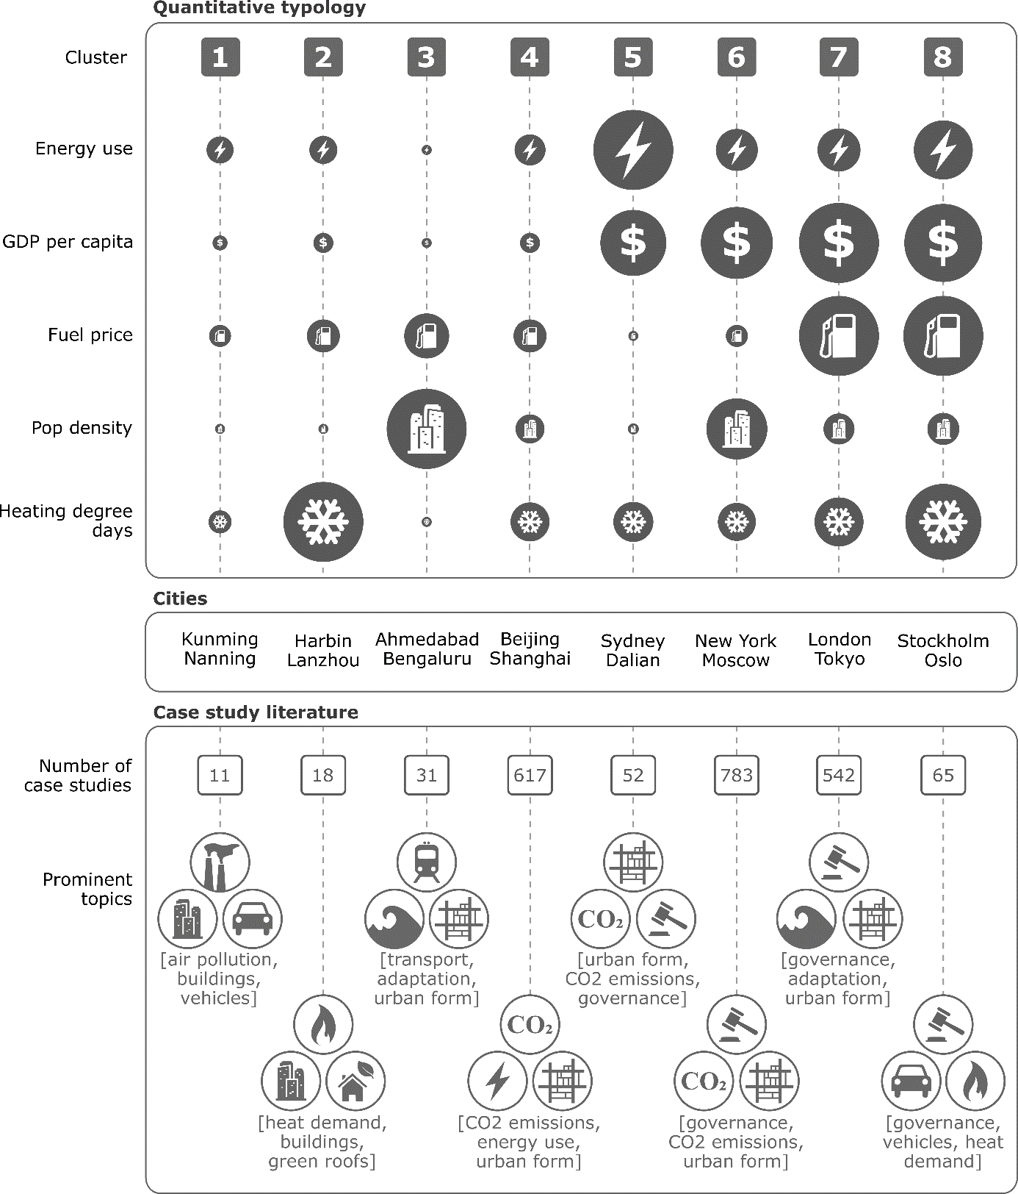

**Figure 5: Linking typologies and case study literature.** The quantitative typology of urban energy use drivers are scaled linearly by diameter, using data from ref 5; case study literature and topic analysis from this study. As in Figure 3, topic scores are summed within each city type, with the highest scoring three topics displayed.

The approach again faces constraints in terms of available data and cases, which are sparse for smaller cities and particular clusters. Crowdsourcing and spatial methods are already closing data gaps in these cities 51; such efforts need to be matched by a shift in case study focus. Yet the proposed approach promises to address a key issue therein: what are the peer groups for smaller cities? With the predominant focus of cases and comparisons on a set of familiar mega-cities (often sharing quite similar attributes), it is far less obvious how comparative work can be adapted for a much larger set of small and medium-sized cities. By narrowing the scope of peers, and bringing cases that do exist to the forefront, typologies provide the entry point to the systematic comparisons of smaller cities that are currently missing.

But the importance of comparisons across diverse contexts should also not be overlooked. Implicit in much sustainability research is an asymmetry of knowledge exchange: cases in the global North are relevant for the South, but not vice-versa 52. These cul-de-sacs should be avoided with the flexible use of typologies that suit the question at hand – and on the understanding that not all production and consumption decisions are shaped by income 53. Extensive surveys of the literature across all cities also have an important role, for instance to consolidate the wealth of life cycle and emissions inventory cases, thereby examining the collective impacts of cities and verifying top-down accounts 51. Wide case surveys could also contribute to the verification of typologies, confirming the importance of some factors, rejecting others, or raising additional qualitative factors that are currently poorly understood. In this sense, a strong commitment to integrating case study knowledge requires embracing interdisciplinary and complementary methods, and developing new routes towards research synthesis.

## Conclusion

As cities begin to implement local climate mitigation agendas, it will become increasingly important to build a supportive evidence base. Urban climate solutions, where demand-side measures dominate, epitomise complex interventions. They involve everyday habits and behaviours, across multiple actors and governance scales. Evidence-based policy for such interventions requires an understanding of not just the potential and effectiveness of different policies, but the reasons why interventions work or do not work under varying contexts and circumstances 54. Case studies have a central role in uncovering these contextual conditions, but the current state of the literature in terms of city coverage, topic scope, and progress on comparative studies and systematic reviews is basically unknown. Nor has there been adequate discussion of how to learn from and utilise current and future case studies, rendering them an unexploited resource. In this perspective we address these issues and suggest ways forward.

Our analysis suggests there is a wealth of case study evidence available – 3,440 studies to date. Since we captured only ‘climate mitigation’ articles in a broad brush approach, this is likely an underestimate that does not reveal the full extent of sector-specific research 6. Manually scoping this number of studies to gain an overview of the field would be difficult and highly time consuming. But with computer assisted methods, including scientometrics and computational linguistics, a comprehensive evidence map can be quickly developed. This analysis identifies three biases in urban mitigation cases: (1) A substantial and unwarranted bias exists towards studies on large cities and those situated in the global North. In contrast, only a handful of studies exist on African cities and smaller agglomerations in Asia – where the majority of current and future urban growth will take place. (2) The topic space is dominated by demand-side measures, but shows strong regional biases. Cases in Africa emphasise adaptation and fail to provide evidence on upcoming issues of urban form and infrastructure build-out. The literature on Asian cities is strongly focused on emissions accounting and needs to explicitly address governance and sustainability issues. (3) The existing comparative research lacks international scope and tends to be under-justified on conceptual grounds. In addition, few attempts have been made to systematically review urban case study research.

These issues require a shift in focus, including a diversification of contexts and topics. Locating research efforts, stakeholder engagement and policy advocacy in growing cities and developing regions will be instrumental to avoiding lock-in and realising compact, low-carbon urban forms that can tackle the coming mitigation challenge 12,38. Doing so would resonate with calls to develop global urban solutions and ‘leave no city behind’ in scientific assessments 1,2,43.

A further focus on synthetic urban research is needed. Consolidating existing cases on individual cities provides an opportunity to quickly build a more comprehensive overview of interlinked urban mitigation issues, although only for a small subset of cities. To progress our understanding of more diverse contexts, urban data science and typologies offer a route to learning from bottom-up cases within peer groups of cities. Such an approach would address pervasive concerns of generalisability in urban research, and with the case study method specifically. Overviews and systematic maps of the case study literature provide an entry point to these projects. Capturing study locations, topics, comparative research and available reviews enable progress and knowledge gaps in the field to be tracked, even as the quantity of studies rapidly grows. Inspiration can also be drawn from other fields of scientific inquiry that face similar challenges, including urban adaptation research 55 and land-use science 56.

Above all, a culture of learning and synthesis is called for: from investigating unknown contexts, to making individual case studies available for systematic reviews, to increased ambition in comparative research, to more comprehensive reviews of the case study literature. These are public goods that require significant investments in time and effort. But for a truly synthetic global urban science, no case study should be left behind.

**Methods**

*Literature scoping*

A search query combining ‘urban’ and ‘mitigation’ synonyms was used in the Web of Science and Scopus to identify relevant documents (Table 2). As of March 2018 this search returned 12,918 documents (unconstrained by language or document type).

|  |  |
| --- | --- |
| Urban synonyms | Mitigation synonyms |
| ("urban*" OR "municipal" OR "city" OR "cities" OR "metropolitan") | (“Paris Agreement” OR “low carbon” OR "decarboni*ation" OR (“energy” OR “carbon” OR “CO2” OR “GHG” OR “greenhouse gas” OR “climat*”) NEAR/3 ("mitigation" OR "reduc*" OR "polic*" OR "governance")) |

**Table 2: Search query for urban climate mitigation literature.** The two strings are combined with an ‘AND’ operator and entered as a topic search in the Web of Science, and a title-abstract-keyword search in Scopus.

*Identifying cases*

To identify urban case studies we searched the abstracts of the 12,918 documents for city names. We use the Geonames database of geographic locations, which aggregates national survey data, travel destinations and open sourced contributions, specifying a global list of cities with populations greater than 15,000. 3,440 studies in the document set refer to a city in the abstract or title. Double counting where an article mentions multiple city names, we obtain 4,730 case studies on individual cities. We excluded the text “Paris Agreement” and “Kyoto Protocol” from abstracts to avoid false hits that refer to these climate treaties.

*Topic modelling*

We use the sklearn library in python to process and produce a topic model from the 3,440 studies mentioning a city in the abstract 57. Weighting terms in each document by the inverse of the number of times they appear across the corpus (tf-idf), we apply non-negative matrix factorisation 58 to a matrix of documents × terms. The resulting matrices, whose product approximates the document-term matrix, are used to label documents by topic, and topics by term. Higher document-topic scores indicate documents where words associated with the topic appear; higher topic-term scores indicate the strength of an association between a word and a topic. The marginal topic distribution for each topic denotes the sum of document-topic scores for that topic as a proportion of the sum of all document-topic scores.

Important and subjective choices in the analysis are the number of topics to specify and the names given to the resulting topics. We review multiple topic models in the range of 15-25 topics, choosing 17 due to the marginal (subjective) gain in information given by an additional topic. We manually assign names to the topics (shown in SI Text Table 1), based on a review of the associated keywords and strongly correlating documents.

To analyse the prominence of topics within groups of papers (Figure 3), we sum their topic scores, selecting the top 3 for simplicity. In part, these results will be driven by the general prominence of topics across the whole document set (e.g. ‘governance’ more likely appears as a prominent topic than ‘urban ecology’). To count publications on given topics (Figure 4), we assign a document-topic score threshold of 0.02, reviewing a random sample of papers to confirm this choice.

*Future-looking case studies*

To identify case studies with a future-looking orientation (mitigation scenarios, for example, or projections of urbanisation, land-use, or energy demand), we manually search for the following keywords within abstracts: “scenario” OR “2020” OR “2025” OR “2030” OR “2040” OR “2045” OR “2050”. A random selection and screening of these documents showed they were broadly in line with our expectations.

*Systematic reviews*

To identify systematic reviews of the case study literature (Table 2) we manually search the original document set (12,918 studies) for the following keywords: “ meta-“ OR “systematic review” OR “scoping” OR “narrative review” OR “qualitative comparative analysis” OR “QCA” OR “scientometric” OR “synthesis”. The results are hand filtered to exclude non-urban, non-mitigation and non-review articles.

# References

1. Acuto, M., Parnell, S. & Seto, K. C. Building a global urban science. *Nat. Sustain.* **1,** 2–4 (2018).

2. Acuto, M. & Susan, P. Leave no city behind. *Science (80-. ).* **352,** 873 (2016).

3. Minx, J. C., Callaghan, M., Lamb, W. F., Garard, J. & Edenhofer, O. Learning about climate change solutions in the IPCC and beyond. *Environ. Sci. Policy* **77,** (2017).

4. Creutzig, F., Baiocchi, G., Bierkandt, R., Pichler, P.-P. & Seto, K. C. Global typology of urban energy use and potentials for an urbanization mitigation wedge. *Proc. Natl. Acad. Sci.* (2015). doi:10.1073/pnas.1315545112

5. Grandin, J., Haarstad, H., Kjærås, K. & Bouzarovski, S. The politics of rapid urban transformation. *Curr. Opin. Environ. Sustain.* **31,** 16–22 (2018).

6. Lamb, W. F., Callaghan, M. W., Creutzig, F., Khosla, R. & Minx, J. C. The literature landscape on 1.5°C Climate Change and Cities. *Curr. Opin. Environ. Sustain.* **30,** 26–34 (2018).

7. UN DESA. *World Urbanization Prospects: The 2014 Revision*. (United Nations, Department of Economic and Social Affairs, Population Division, 2015).

8. Kartha, S. *et al.* Cascading biases against poorer countries. *Nat. Clim. Chang.* **8,** 348–349 (2018).

9. Sallis, J. F. *et al.* Use of science to guide city planning policy and practice: how to achieve healthy and sustainable future cities. *Lancet* **388,** 2936–2947 (2016).

10. Gonzalez-Brambila, C. N., Reyes-Gonzalez, L., Veloso, F. & Perez-Angón, M. A. The scientific impact of developing nations. *PLoS One* **11,** (2016).

11. Wiedenhofer, D., Lenzen, M. & Steinberger, J. K. Energy requirements of consumption: Urban form, climatic and socio-economic factors, rebounds and their policy implications. *Energy Policy* **63,** 696–707 (2013).

12. Creutzig, F. *et al.* Urban infrastructure choices structure climate solutions. *Nat. Clim. Chang.* **6,** 1054 (2016).

13. Creutzig, F. *et al.* Towards demand-side solutions for mitigating climate change. *Nat. Clim. Chang.* **8,** 260–271 (2018).

14. Steinberg, P. F. Can We Generalize from Case Studies? *Glob. Environ. Polit.* **15,** 152–175 (2015).

15. Rudel, T. K. Meta-analyses of case studies: A method for studying regional and global environmental change. *Glob. Environ. Chang.* **18,** 18–25 (2008).

16. Lieberman, E. S. Nested Analysis as a Mixed-Method Strategy for Comparative Research. *Am. Polit. Sci. Rev.* **99,** 435–452 (2005).

17. Bennett, A. & Elman, C. Qualitative research: Recent developments in case study methods. *Annu. Rev. Polit. Sci.* **9,** 455–476 (2006).

18. Storper, M. & Scott, A. J. Current debates in urban theory: A critical assessment. *Urban Stud.* **53,** 1114–1136 (2016).

19. Advisory Committee for Environmental Research and Education. *Sustainable Urban Systems: Articulating a Long-Term Convergence Research Agenda. A Report from the NSF Advisory Committee for Environmental Research and Education. Prepared by the Sustainable Urban Systems Subcommittee.* (2018).

20. Berrang-Ford, L., Pearce, T. & Ford, J. D. Systematic review approaches for climate change adaptation research. *Reg. Environ. Chang.* (2015). doi:10.1007/s10113-014-0708-7

21. Sorrell, S. Improving the evidence base for energy policy: The role of systematic reviews. *Energy Policy* **35,** 1858–1871 (2007).

22. Haddaway, N. R. & Macura, B. The role of reporting standards in producing robust literature reviews. *Nat. Clim. Chang.* **8,** 444–453 (2018).

23. Kastner, M., Antony, J., Soobiah, C., Straus, S. E. & Tricco, A. C. Conceptual recommendations for selecting the most appropriate knowledge synthesis method to answer research questions related to complex evidence. *J. Clin. Epidemiol.* **73,** 43–49 (2016).

24. Srivastava, A., Van Passel, S. & Laes, E. Assessing the success of electricity demand response programs: A meta-analysis. *Energy Res. Soc. Sci.* **40,** 110–117 (2018).

25. Francis, L. F. M. & Jensen, M. B. Benefits of green roofs: A systematic review of the evidence for three ecosystem services. *Urban For. Urban Green.* **28,** 167–176 (2017).

26. Song, X. P., Tan, P. Y., Edwards, P. & Richards, D. The economic benefits and costs of trees in urban forest stewardship: A systematic review. *Urban For. Urban Green.* **29,** 162–170 (2018).

27. Newig, J. & Fritsch, O. *The case survey method and applications in political science*. **49,** (2009).

28. Nijkamp, P. & Pepping, G. A Meta-analytical Evaluation of Sustainable City Initiatives. *Urban Stud.* **35,** 1481–1500 (1998).

29. Li, Y. & Babcock, R. W. Green roofs against pollution and climate change. A review. *Agron. Sustain. Dev.* **34,** 695–705 (2014).

30. Lwasa, S. *et al.* Urban and peri-urban agriculture and forestry: Transcending poverty alleviation to climate change mitigation and adaptation. *Urban Clim.* **7,** 92–106 (2014).

31. Brands, E. Prospects and challenges for sustainable sanitation in developed nations: a critical review. *Environ. Rev.* **22,** 346–363 (2014).

32. Lwasa, S. *et al.* A meta-analysis of urban and peri-urban agriculture and forestry in mediating climate change. *Curr. Opin. Environ. Sustain.* **13,** 68–73 (2015).

33. Kwan, S. C. & Hashim, J. H. A review on co-benefits of mass public transportation in climate change mitigation. *Sustain. Cities Soc.* **22,** 11–18 (2016).

34. Garcez, C. A. G. What do we know about the study of distributed generation policies and regulations in the Americas? A systematic review of literature. *Renew. Sustain. Energy Rev.* **75,** 1404–1416 (2017).

35. Deng, H.-M., Liang, Q.-M., Liu, L.-J. & Anadon, L. D. Co-benefits of greenhouse gas mitigation: a review and classification by type, mitigation sector, and geography. *Environ. Res. Lett.* **12,** (2018).

36. Sovacool, B. K. & Brown, M. A. Twelve metropolitan carbon footprints: A preliminary comparative global assessment. *Energy Policy* **38,** 4856–4869 (2010).

37. Grubler, A. *et al.* in *Global Energy Assessment - Toward a Sustainable Future* 1307–1400 (Cambridge University Press, 2012).

38. Karen C., S. *et al.* in *Climate Change 2014: Mitigation of Climate Change. Contribution of Working Group III to the Fifth Assessment Report of the Intergovernmental Panel on Climate Change* 923–1000 (Cambridge University Press, 2014). doi:10.1017/CBO9781107415416.018

39. Rosenzweig, C. *et al.* *ARC3.2 Summary for City Leaders*. (Columbia University, 2015). doi:10.1017/CBO9780511783142

40. Baiocchi, G., Creutzig, F., Minx, J. & Pichler, P. P. A spatial typology of human settlements and their CO2 emissions in England. *Glob. Environ. Chang.* **34,** 13–21 (2015).

41. Glaeser, E. L. & Kahn, M. E. The greenness of cities: Carbon dioxide emissions and urban development. *J. Urban Econ.* **67,** 404–418 (2010).

42. Seto, K. C., Golden, J. S., Alberti, M. & Turner, B. L. Sustainability in an urbanizing planet. *Proc. Natl. Acad. Sci.* **114,** 201606037 (2017).

43. McPhearson, T. *et al.* Scientists must have a say in the future of cities. *Nature* **538,** 165–166 (2016).

44. Solecki, W. *et al.* City transformations in a 1.5 °C warmer world. *Nat. Clim. Chang.* **8,** 177–185 (2018).

45. Ürge-Vorsatz, D. *et al.* Locking in positive climate responses in cities. *Nat. Clim. Chang.* **8,** 174–177 (2018).

46. Scott, A. J. & Storper, M. The nature of cities: The scope and limits of urban theory. *Int. J. Urban Reg. Res.* **39,** 1–15 (2015).

47. Shove, E., Watson, M. & Spurling, N. Conceptualizing connections: Energy demand, infrastructures and social practices. *Eur. J. Soc. Theory* **18,** 274–287 (2015).

48. Bartlett, S. & Satterthwaite, D. (Eds. . *Cities on a Finite Planet: Towards Transformative Responses to Climate Change*. (Routledge, 2016). doi:10.4324/9781315645421

49. Creutzig, F. *et al.* Upscaling urban data science for global climate solutions. *Glob. Sustain.*

50. Creutzig, F. How fuel prices determine public transport infrastructure, modal shares and urban form. *Urban Clim.* **10,** 63–76 (2014).

51. Moran, D. *et al.* Carbon footprints of 13,000 cities. *Environ. Res. Lett.* 0–18 (2018). doi:https://doi.org/10.1088/1478-3975/aa9768

52. Nagendra, H. The global south is rich in sustainability lessons that students deserve to hear. *Nature* (2018). doi:10.1038/d41586-018-05210-0

53. Lamb, W. F. & Steinberger, J. K. Human well-being and climate change mitigation. *Wiley Interdiscip. Rev. Clim. Chang.* **8,** 1–16 (2017).

54. Pawson, R., Greenhaigh, T., Harvey, G. & Walshe, K. Realist review - a new method of systematic review designed for complex policy interventions. *J. Health Serv. Res. Policy* **10,** 21–34 (2005).

55. Vogel, B. & Henstra, D. Studying local climate adaptation: A heuristic research framework for comparative policy analysis. *Glob. Environ. Chang.* **31,** 110–120 (2015).

56. Margulies, J. D., Magliocca, N. R., Schmill, M. D. & Ellis, E. C. Ambiguous geographies: Connecting case study knowledge with global change science. *Ann. Am. Assoc. Geogr.* **106,** 572–596 (2016).

57. Pedregosa, F. *et al.* Scikit-learn: Machine Learning in Python. *J. Mach. Learn. Res.* **12,** 2825–2830 (2011).

58. Lee, D. D. & Seung, H. S. Learning the parts of objects by non-negative matrix factorization. *Nature* **401,** 788–91 (1999).

# Author contributions

W.F.L., F.C. and J.C.M. designed the research. W.F.L. and M.W.C. performed the analysis. W.F.L. wrote the manuscript with contributions from all authors.

# Additional information

Correspondence and requests for materials should be addressed to W.F.L.

# Competing financial interests

The authors declare no competing financial interests.